LS VISION 5MP IP Camera LS-ND11503

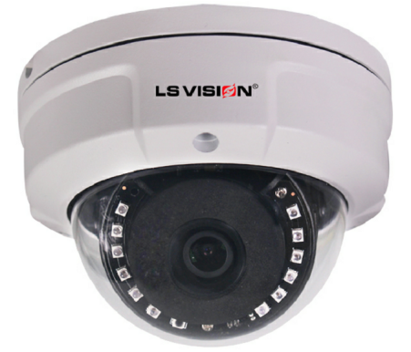
Features:
- 1/2.9" Sony CMOS sensor
- Full HD resolution 2592*1944
- Ultra low illumination 0.01Lux
- Day/Night (ICR), AWB, 2D/3D-DNR, IR-CUT
- D-WDR, Motion Detection, Privacy Mask, Mirror, rotate
- RTSP and Onvif compatible
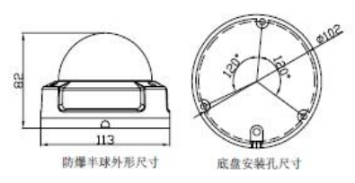
- H.265/H.264 dual-stream media server
- Easy-to-use P2P Cloud service
- Multiply web browser, PC Client, mobile APP remote access
- Optional customization Lens/Audio, etc.
- Lightning protection 4000V
- Strong water-proof housing, IP66
- Support POE 48V

Technical Specifications:
Model | LS-ND11503
Camera
Image Sensor | 1/2.9" Sony CMOS
Effective Pixels | 2592(H)×1944 (V)
Electronic Shutter | AUTO, 1/25s ~ 1/100000s
Min. Illumination | 0.01Lux@F1.2(AGC ON), 0Lux IR on
Day/Night | Auto/Color/(B/W)/Timing
WDR | Digital WDR
White Balance | Auto
AGC/BLC | Support
DNR | 2D/3D DNR
Other | Multi-lines OSD, Motion Detection, Privacy Mask, Mirror, Rotate
Encode
Embedded Solution | SSC337
Video Standard | H.265/H.264
Video Resolution | Main stream: 2592×1944@15fps/2560×1440@25fps/2048×1520@25fps/  1080P/720P@30fps  Sub stream: D1/VGA/360P@30fps, etc.
Video Bitrates | 32Kbps - 6Mbps, VBR/CBR
Audio Standard | G711U/G711A/ACC, optional
IR Led
IR Led | 12pcs Leds
IR Distance | 20M
Lens
Focal length | 3.6/6/8mm lens
Optional Function
Audio,lens,etc.
Network Services
Protocol | HTTP/RTSP/RTMP/DHCP/NTP/ONVIF/P2P/UPNP/GB28181, etc.
P2P | Yes
Web | IE , Firefox, etc.
Media | CMS, Android, IOS
ONVIF | 2.6 compatible
General
Network Port | 1-RJ45, 100Mbps, POE optional
Power Supply | Support POE 48V &12 VDC ± 10%
Power Consumption | < 7W
Operating Temp. | -30℃-(+60)℃, 10%-90%RH

*This statement is subject to change witho ut notice

