1. System specification

Smart home is based on a residential platform, using integrated wiring technology, network communication technology, security technology, automatic control technology, audio and video technology to integrate the facilities related to home life to build an efficient management system for residential facilities and family schedule affairs, and improve Home safety, convenience, comfort, and realize an environmentally friendly and energy-saving living environment.

LS VISION'S smart home battery camera with smart home system supports APP linkage, infrared night vision, remote alarm, two-way voice intercom etc. In practical applications, the introduction of ultra-low-power battery-powered smart network camera technology solutions completely realizes the wireless solution of smart network cameras without power cords and network cables, allowing ordinary users to quickly and conveniently install smart network cameras indoors and outdoors , Get a better experience.

- Smart home system topology diagram

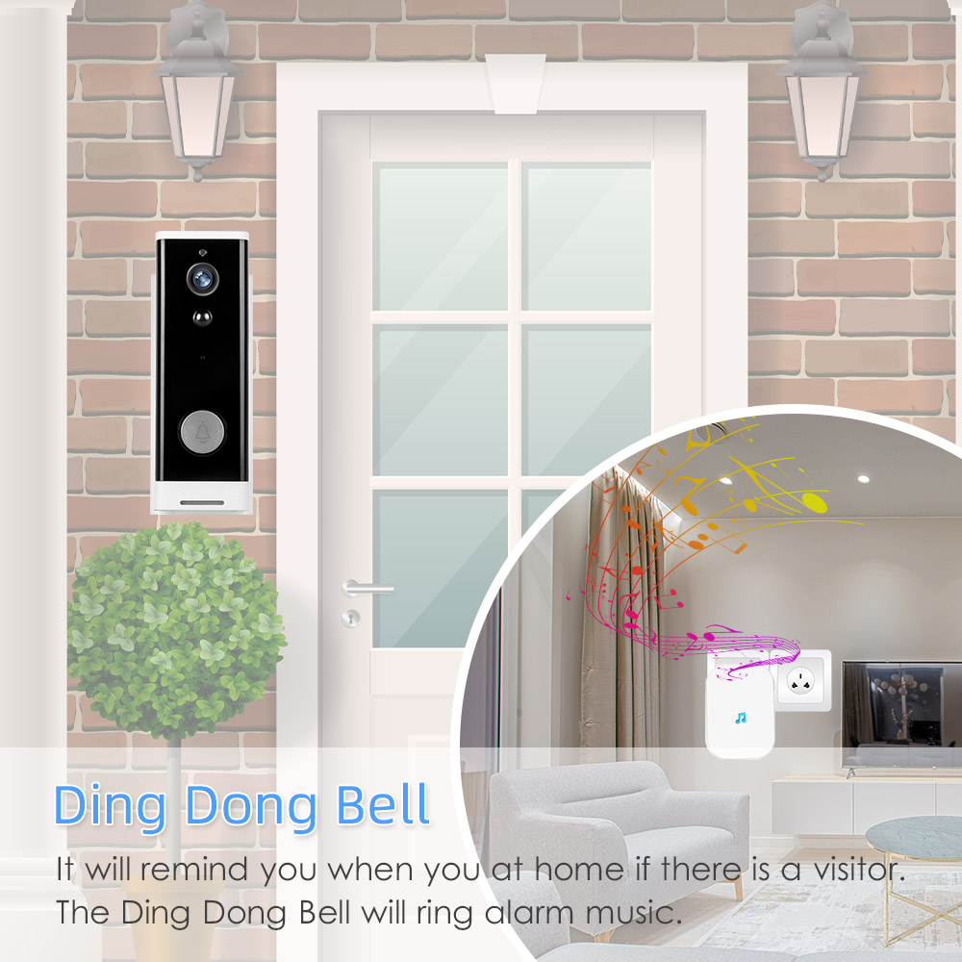
3. Equipment composition

The smart home system is mainly composed of control host, video doorbell, monitoring host and camera, wireless camera, smart socket, door sensor switch, PIR camera, smart switch, temperature controller, smart socket, PIR sensor, gas sensor, fire sensor and Access control system composition.

1) Foyer
The foyer is the entrance and exit of the home. The intelligent design of this place should fully reflect the convenience and humanization design concept, and it should be simple and practical.

A scene panel is installed at the entrance of the hall, and scene combinations can be set.
- Before going out, press "Leaving Home Scene" and all devices will enter the state preset by the owner. The lights are all turned off, no need to power off the standby equipment, and the security system enters the working state. The video doorbell will push visitor information

B. A human body detector is installed at the entrance door. When you go home and enter the door, you can press the "Disarm" button with a mobile phone or a portable scene panel. Otherwise, when the door is opened, the human body detector will transmit a signal to the host, and the host will dial "The device" dialed out five set of phone numbers to notify the owner that someone had broken in. This is part of security to prevent thieves from breaking in.

C. When going home, press the scene control switch "home mode" button: the curtains are closed, the lights are turned on, the air conditioner is turned on, and the TV is tuned to the set channel. The video doorbell will push the visitor's information, and it can talk remotely to notify the owner to open the door.

2) Restaurant

On the way home, use the mobile phone to control the smart socket to turn on the water heater, the rice cooker is turned on, the bath water has been boiled at home, after the shower, a few dishes are cooked, the rice in the rice cooker has been cooked, then press "dining mode" "The lights in the living room are turned off, and the lights in the dining room are adjusted to the proper brightness, creating a romantic atmosphere.

3) Living room

On the coffee table in the living room, there is a mobile tablet computer (Android or ios), which can be used to control the lights, electrical appliances, etc. at home. After reading the news after a meal, if you want to watch your favorite blockbuster, press the theater mode: curtains When closed, the lights are turned off, and the TV, DVD, and audio system are turned on; therefore, the living room needs to install smart switches, smart sockets, curtain motors, curtain controllers, infrared transponders, smart gateways, smart remote controls and other equipment.

4) Bedroom

The bedroom is the most important place in the home, as well as a place for the owner to rest. All intelligent design should be around convenience, practicality, enjoyment, comfort, humanization, romance, and warmth. The intelligent control of the lights in the bedroom cannot be less, lying on the bed, press the "reading scene" on the scene panel, other lights turn off, the bedside table lamp lights up, it is convenient for you to read the information, tired, going to sleep, press All the lights of the "sleeping scene" on the scene panel are turned off, and the security system is activated, eliminating the trouble of getting up and turning off the lights.
A telephone dialing emergency button is installed at the bedside of the bedroom. If the child or parent encounters an emergency at home, press the "emergency button", the telephone dialer will dial the owner's phone to notify the emergency situation at home.

5) Toilet:

Equipped with a smart socket, which can control the working time of the water heater regularly and remotely. Install a flooding alarm, remote alarm reminder, to prevent forgetting to turn off the faucet when going out.

6) Kitchen:

Install smart sockets to control rice cookers, toasters, microwave ovens and other equipment, smoke alarms can detect fire conditions, and gas sensors can detect natural gas leaks and alarm for protection

7) Remote control:

NVRs and cameras are installed in the living room, doorway, and yard of the home, which are connected to the host through the network. You can see the situation at home through the computer and mobile Internet during the noon break. The host can see the situation at home through the camera anytime and anywhere.

8) Security alarm system:

When leaving home, press the "protection" button, door sensor, human sensor, and start to work. If a thief breaks in, the phone dialer will automatically call the owner and call the two phone numbers that have been set at the same time. Prompt the host that there is a special situation at home. NVR and cameras can monitor and record the home environment in real time, trace back lost items through video playback, and ensure the safety of property.

PIR human sensor and PIR camera can be used in different places with security requirements. When it senses human movement, it can directly send alarm information to background personnel through mobile phones; in addition, combine this product with sound and light alarms, when PIR is triggered When, the sound and light alarm will alarm immediately;

Door magnetic switch: Real-time sensing of the opening and closing status of doors and windows, etc., always worrying whether the doors and windows at home are turn off? Take out the phone and see at a glance. Door and window magnetic sensors are widely used in various scenarios, whether it is family doors, windows, refrigerators, safes, store doors, items that need to be transported safely, or isolation monitoring during an epidemic, this product can be used

If a woman living in a single apartment uses the door sensor and linkage to build an arming mode when sleeping at night, relying on linkage to scare away the thief through an alarm.
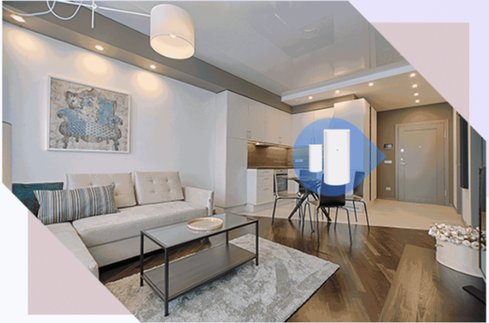

Video surveillance video: continuous video surveillance of key areas, which can be recorded and saved;
Remote monitoring: You can view the home surveillance video screen at any time through terminals such as mobile phones and computers;
Anti-theft and fire alarm: door and window intrusion alarm, the system can immediately notify the owner via SMS. When the house is on fire or the smoke concentration is too high, the smoke alarm will send out an alarm signal to notify the owner and the community security that there is a dangerous situation in the home as soon as possible, and deal with it in time.

Safe precautions: LS-WB520 battery camera can set up a care area to monitor home safes and other belongings and directly feed back the alarm to the user's mobile phone;

Remote care and emergency help for the elderly: The elderly can interact and communicate with their children through video at any time through this system; emergency help buttons are installed on the bedside, bathroom, living room, etc., and the system can be used immediately when the elderly is sick or other emergency situations. SMS and phone calls to notify owners, communities, community hospitals, etc.;

Mobile phone remote visualized doorbell: Install LS-WD801 doorbell, users can remotely observe the door area through mobile phone, and intelligently push visiting information. When relatives and friends are visiting and no one is at home, the head of the household can also talk to the visiting customers remotely;

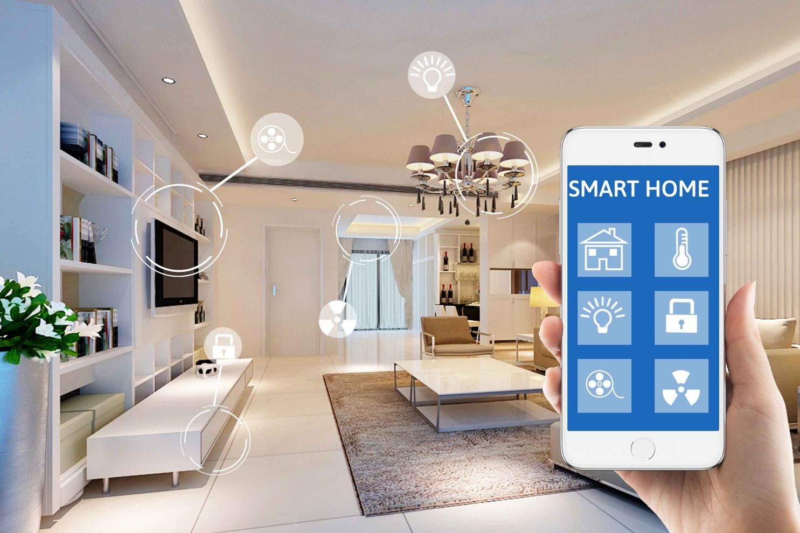
Smart gateway: It can be connected to smart sockets, smart switches, alarm sensors, and control home electrical equipment through mobile phones, tablets or AI speakers.

