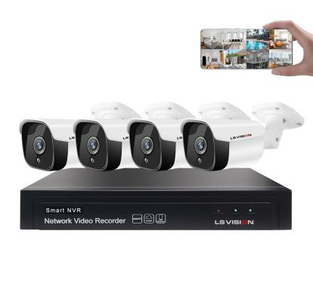**H.265/H.264 4CH 5MP POE NVR Kit Model :LS-PK2504**

**Key Features:**

* 8CH 5MP POE NVR + 4pcs 5MP POE IP Bullet cameras
* Convenient Installation
* Plug and play
* P2P, offer friendly APP
* Support 1 SATA HDD
* support POE IEEE802.3af
* Quick setup, with built-in multilingual management page

**NVR Specification:**

|  |  |
| --- | --- |
| **Model** | **LS-PK2504** |
| **Operating System** | Embedded Linux OS |
| **DSP** | Hi3536D |
| **Compression** | H.265/H.264 |
| **AV(video)input** | |
| **Network Video** | 8CH 5MP |
| **Network video input broad bank** | 40Mbps |
| **AV (video) output** | |
| **HDMI output** | 1ch，resolution：1024x768，1366x768，1440x900,1920x1080p |
| **VGA output** | 1ch，resolution：1024x768，1366x768，1440x900,1920x1080p |
| **AV CODEC Specification** | |
| **videotape Resolution** | 1080P/5MP |
| **synch-playback** | 4CH |
| **Video Control** | |
| **Video/Capture mode** | Manual、Time、 Alarm |
| **Playback mode** | Real time、Routine、Event、External file playback |
| **Backup** | USB backup |
| **Hard Disk** | |
| **Type** | 1*SATA interface |
| **Max Hard disk Capacity** | 8 TB at most for each |
| **External Interface** | |
| **Network Interface** | 1 RJ45 10M/100M+8pcs POE |
| **USB Interface** | 2 USB 2.0 |
| **Network Control** | |
| **Protocol** | UPnP (Plug and Play), ONVIF (Version 2.4 is supported),  NTP (Network Time Calibration), SADP (Device Network Search), SMTP (Mail Service), PPPoE (Dial-up Internet access), DHCP (automatically obtain IP). |
| **Others** | |
| **Power Supply** | DC52V 2.3A |
| **Power Consumption (W)** | ≤20W（Without hard drive） |
| **Operate Temperature (°C)** | -10℃~+55℃ |
| **Working Humidity (%) RH** | 10%~90% |
| **Size** | 255mm*220mm*43mm |
| **Weight（excluding HDD）** | ≤2Kg |

**IPC Specification:**

|  |  |
| --- | --- |
| **Model** | **/** |
| **Sensor** | 1/2.9" Sony CMOS |
| **Compression** | H.265/H.264 |
| **DSP** | SSC337+1/2.9”Sony CMOS |
| **Signal System** | PAL/NTSC |
| **Resolution** | 2592*1944 16 : 9 High Defination |
| **Minimum illumination** | 0.01Lux@F1.2(AGC ON), 0Lux IR on |
| **Shutter** | AUTO, 1/25s ~ 1/100000s |
| **Lens** | 3.6mm ,Optional 6/8 mm lens |
| **OSD** | Date Time & Title |
| **White Balance** | Auto |
| **WDR** | Digital WDR |
| **Day&Night** | Auto/Color/(B/W)/Timing |
| **DNR** | 2D/3D DNR |
| **Mirror/Flip** | On / Off |
| **Video Resolution** | Main stream: 2592×1944@15fps/2560×1440@20fps/2048×1520@25fps/  1080P/720P@30fps  Sub stream: D1/VGA/360P@25fps, etc. |
| **Protocol** | HTTP/RTSP/RTMP/DHCP/NTP/ONVIF/P2P/UPNP/GB28181, etc. |
| **IR Led** | 18pcs Leds |
| **IR Distance** | 20M |
| **Interface** | 1 RJ45 /POE |
| **General Specification** | |
| **Working Temperature/Humidity** | -20℃ to +60℃ / 20% to 90% RH |
| **Power Input** | Support POE 48V &DC 12 V ± 10% |
| **Power consumption** | ≤7W |
| **Size** | 185(L)×115(W)×95(H)mm |
| **Weight** | 0.5Kg |
| **Level of Protection** | IP66 |

If there are any changes, will not notice additionally