Low power solar 4G bullet camera Model :LS-4GS06
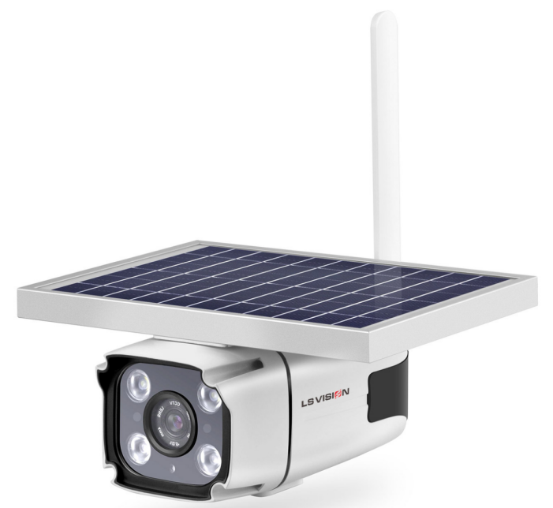

Key Features：

1. No need for external electricity, solar power generation and built-in lithium battery power supply;
2. No need to connect the network cable, built-in 4G module, support 4G frequency band selection in different countries；
3. Microwave motion detection technology:Actively detection in 0.6S,Fast,longer and wider range detection,Not affected by environment, temperature and reflect light.
4. Remote viewing by mobile APP (Mycam);
5. Human body movement triggers alarm and video recording;
6. Local storage, cloud storage;
7. The installation is simple, install by yourself, no need to hire professional construction personnel;

Application scenarios：
Doors of homes, yards, fish ponds, orchards, farms, mines, construction sites, and all places where electricity and wiring are not convenient.

Specification:
model: | LS-4GS06
color: | white
Material | Metal
Induction principle: | HMD（Human Motion Detection-microwave）
CPU: | T21Z/T31Z
Sensor: | F23/2063 2mp 1/2.7" CMOS
4G module: | Qualcomm SIM7600 Series/V3E
4G frequency: | 4G for APN/Euro/USA/Japan etc options
Network: | TCP/IP，HTTP，TCP，UDP，SMTP，DHCP，DNS，P2P
SIM card: | support
Resolution | 2.0MP
Image size : | 1920*1080
Video compressed format: | H.265
Lens | 4mm
Detection time: | 0.6S
Detection distance | 12m
Detection angle: | 120º
Battery type： | 18650 Li-ion battery
Battery Qty： | Built in 4pcs,2600mAh/pcs
battery capcity: | 10400mAh
Solar panel power: | 5.5W（5.5V/1000mA）
Max Charge Current : | 1000mA
Night vision mode | starlight colorful and white&black combine
Night vision distance | 15M
White light power: | 1.5W LED 0.75W*2
Infrared power: | 1W LED 0.5W*2
Storage: | Support TF Card max 128GB
Working temperature: | -10℃ to 65℃
Working humidity: | 0%-90%RH
Power supply: | solar + battery
Stand-by power consumption: | around 0.05W
Work power consumption: | daytime≤2W, night version ≤2.75W
Waterproof | IP66
Accessories: | camera*1、braket*1、scew pack*1、manual*1、USB cable、Tweezers
optional accessory: | external solar panel, extension cable
CAM size: | 235mm*240mm*115mm
CAM weight: | 1.4kg
Gift box size: | 262*136*275mm
G.W/PCS: | 1.9kg
Carton size: | 695x535×295mm
G.W/CTN: | 21kg
Qty/CTN: | 10pcs /case

