**LS-TI009 Thermal imaging temperature measuring camera**

# Product appearance:

|  |  |
| --- | --- |
| **Models** | **Description** |
| **LS-TI009** | 1-channel HDMI output, 1-channel RJ45 Ethernet, 1-channel alarm output, with black sports school Quasi temperature |

**Product information:**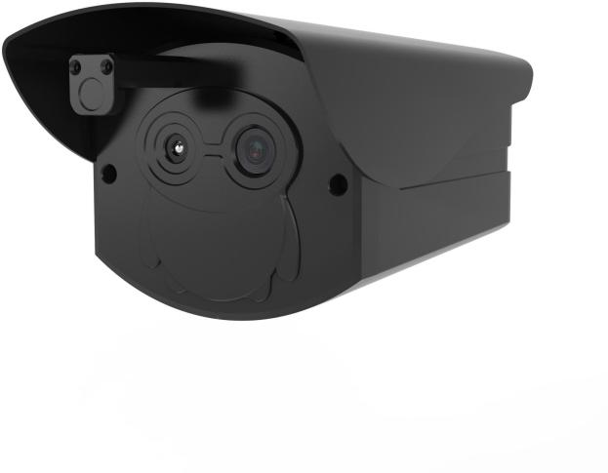

**Product features:**

* Thermal imaging temperature measurement module pixel up to 256x192
* Pixel size 12 μ m. Thermal sensitivity (NETD): ≤ 60mk (@ 25 ℃, f # = 1.1)
* Non contact personnel temperature measurement, accuracy: ± 3 ℃ (target temperature 30 ℃ ~ 50 ℃)
* It has its own facial accurate temperature measurement algorithm to reduce the impact of surrounding high temperature environment
* Human body temeasurement distance: 1 m ~ 3 M
* The 1080p high definition visible light image sensor makes the picture clearer
* Deep intelligent learning algorithm can detect and measure 20 people at the same time
* Maximum output frame rate:
* Visible light: 1920x1080@25fps Thermal imaging: 256x192@25fps
* HDMI output video and voice broadcast, real-time display of the number of passengers and abnormal temperature

# Scope of application:

It can be widely used in the scene of large-scale temperature detection, such as airports, stations, shopping malls, subway stations, schools and other places that need rapid screening of body temperature.

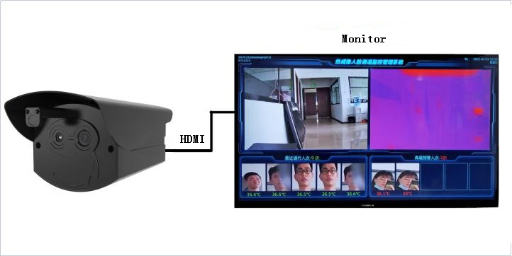

**Technical specifications:**

|  |  |  |
| --- | --- | --- |
| **Model**  **parameter** | | **LS-TI009** |
| **Thermal imaging temperature measuring machine** |
| **Thermal imaging parameters** | **sensor** | Silicon oxide uncooled infrared focal plane detector |
| **resolving power** | 256x192，Pixel size 12 μ m |
| **camera lens** | Focal length: 3.2mm, field angle: 56 ° x 42 |
| **Temperature measurement accuracy** | ± 3 ℃, target temperature 35 ℃ ~ 38 ℃ |
| **Temperature measurement distance** | 1m-3m |
| **Blackbody**  **parameter** | **Effective radiation area** | 15mm*30mm |
| **temperature range** | 30℃-50℃ |
| **Temperature resolution** | 0.01℃ |
| **Stability accuracy** | ≤0.1℃ |
| **Visible mode parameters** | **image sensor** | 1/2.8” 2.0M Pixel Progressive Scan CMOS |
| **Minimum illumination** | [0.05Lux@F1.2](mailto:0.05Lux@F1.2)（Color mode）、[0.01Lux@F1.2](mailto:0.01Lux@F1.2)（black and white mode） |
| **Wide dynamic range** | ≥80dB |
| **Signal to noise ratio** | ≥46dB（AGC OFF） |
| **focal length** | 4mm |
| **Angle of field of view** | Horizontal perspective 84 °、 Vertical view 45 ° |
| **AI** | **Face capture** | Support simultaneous detection of 20 faces, face detection, capture |
| **Abnormal temperature alarm** | Abnormal body temperature voice alarm (default alarm threshold is 37.3 ℃) |
| **Hardware**  **Interface** | **Power interface** | DC12V interface |
| **network interface** | 1 channel 10 / 100BaseT Ethernet, RJ45 interface |
| **Alarm interface** | Support switch alarm signal output, linkage external sound and light alarm |
| **Audio and video interface** | Support 1 channel HDMI high definition audio and video output |
| **storage** | Built in EMMC storage, up to 100000 temperature records can be stored |
| **commonly**  **standard** | **working temperature** | -10℃～42℃ |
| **Working humidity** | 0%-90% RH（non-condensing） |
| **Protection level** | IP64 |
| **Power Supply** | 12VDC |
| **power waste** | ≤6W |
| **Product size** | 220mm*105mm*100mm |
| **weight** | ＜1.2kg |