# 2MP HD WDR IR Motorized Zoom Dome Network Camera

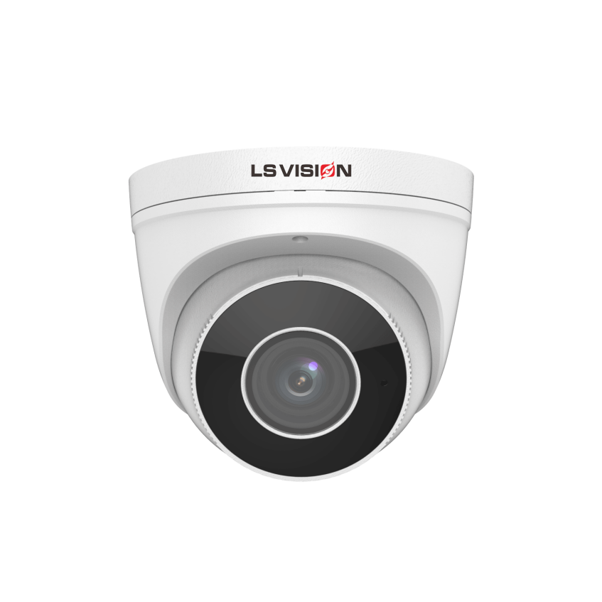LS-PD24201M

## Key Features

* High quality image with 2MP, 1/2.7"CMOS sensor
* 2MP (1920*1080)@30/25fps; 720P (1280*720)@30/25fps
* Ultra 265, H.265, H.264, MJPEG
* 2.8 ~ 12mm motorized zoom lens
* 120dB true WDR technology enables clear image in strong light scene
* Support 9:16 Corridor Mode
* Built-in Mic
* Smart IR, up to 40m IR distance
* Supports 128 G Micro SD card
* Support PoE power supply
* 3-Axis

## Specifications

|  |  |  |  |  |  |  |  |  |
| --- | --- | --- | --- | --- | --- | --- | --- | --- |
|  | LS-PD24201M | | | | | | | |
| Camera | | | | | | | | |
| Sensor | 1/2.7", 2.0 megapixel, progressive scan, CMOS | | | | | | | |
| Lens | 2.8 ~ 12mm, AF automatic focusing and motorized zoom lens | | | | | | | |
| DORI Distance | Lens (mm) | | Detect (m) | | Observe (m) | Recognize (m) | | Identify (m) |
| 2.8 | | 42.0 | | 16.8 | 8.4 | | 4.2 |
| 12 | | 180 | | 72 | 36 | | 18 |
| Angle of View (H) | 108.05°~ 32.59° | | | | | | | |
| Angle of View (V) | 56.81°~ 18.36° | | | | | | | |
| Angle of View (O) | 111.91°~36.53° | | | | | | | |
| Adjustment Angle | Pan: 0° ~ 360° | | | Tilt: 0° ~ 90° | | | Rotate: 0° ~ 360° | |
| Shutter | Auto/Manual, 1 ~ 1/100000s | | | | | | | |
| Minimum Illumination | Colour: 0.01Lux ( F1.6, AGC ON)  0Lux with IR | | | | | | | |
| Day/Night | IR-cut filter with auto switch (ICR) | | | | | | | |
| Digital Noise Reduction | 2D/3D DNR | | | | | | | |
| S/N | >52dB | | | | | | | |
| IR Range | Up to 40m IR range | | | | | | | |
| Wavelength | 850nm | | | | | | | |
| IR On/Off Control | Auto/Manual | | | | | | | |
| Defog | Digital Defog | | | | | | | |
| WDR | 120dB | | | | | | | |
| Video | | | | | | | | |
| Video Compression | Ultra 265, H.265, H.264, MJPEG | | | | | | | |
| H.264 code profile | Baseline profile, Main profile, High profile | | | | | | | |
| Frame Rate | Main Stream: 1080P (1920*1080), Max 30fps; 720P (1280*720), Max 30fps  Sub Stream: 720P (1280*720), Max 30fps; D1 (720*576), Max 30fps; 640*360,Max 30fps; 2CIF(704*288), Max 30fps; CIF(352*288), Max 30fps; | | | | | | | |
| Video Bit Rate | 128 Kbps~6144 kbps | | | | | | | |
| 9:16 Corridor Mode | Supported | | | | | | | |
| OSD | Up to 4 OSDs | | | | | | | |
| Privacy Mask | Up to 4 areas | | | | | | | |
| ROI | Up to 8 areas | | | | | | | |
| Motion Detection | Up to 4 areas | | | | | | | |
| Image | | | | | | | | |
| White Balance | Auto/Outdoor/Fine Tune/Sodium Lamp/Locked/Auto2 | | | | | | | |
| Digital Noise Reduction | 2D/3D DNR | | | | | | | |
| Smart IR | Supported | | | | | | | |
| Flip | Normal/Vertical/Horizontal/180°/90°Clockwise/90°Anti-clockwise | | | | | | | |
| Dewarping | N/A | | | | | | | |
| HLC | Supported | | | | | | | |
| BLC | Supported | | | | | | | |
| Smart | | | | | | | | |
| Behavior Detection | Cross line, intrusion(based on human body detection) | | | | | | | |
| motion detection, tampering alarm, audio detection | | | | | | | |
| General Function | Watermark, IP address filtering, access policy, ARP protection, RTSP authentication, user authentication | | | | | | | |
| Network | | | | | | | | |
| Protocols | IPv4, IGMP, ICMP, ARP, TCP, UDP, DHCP, RTP, RTSP, RTCP, RTMP, DNS, DDNS, NTP, FTP, UPnP, HTTP, HTTPS, SMTP, QoS, SSL, SNMP | | | | | | | |
| Compatible Integration | ONVIF (Profile S, Profile G, Profile T) | | | | | | | |
| Web Browser | Plug-in required live view: IE9+, Chrome 41 and below, Firefox 52 and below | | | | | | | |
| Plug-in free live view: Chorme 57.0+, Firefox 58.0+, Edge 16+, Safari 11+ | | | | | | | |
| Audio | | | | | | | | |
| Audio Compression | G.711 | | | | | | | |
| Suppression | Supported | | | | | | | |
| Sampling Rate | 8KHZ | | | | | | | |
| Storage | | | | | | | | |
| Edge Storage | Micro SD, up to 128GB | | | | | | | |
| Network Storage | ANR,NAS(NFS) | | | | | | | |
| Interface | | | | | | | | |
| Network | 10/100M Base-TX Ethernet | | | | | | | |
| Built-in Mic | Supported | | | | | | | |
| General | | | | | | | | |
| Power | DC 12V±25%, PoE (IEEE 802.3af) | | | | | | | |
| Power consumption: Max 8.5W | | | | | | | |
| Material | Metal | | | | | | | |
| waterproof | IP67 | | | | | | | |
| Working Environment | -30°C ~ 60°C (-22°F ~ 140°F), Humidity: ≤95% RH (non-condensing) | | | | | | | |
| Strorage Environment | -30°C ~ 60°C (-22°F ~ 140°F), Humidity: ≤95% RH (non-condensing) | | | | | | | |
| Product size/weight | | Φ129 x 110mm/0.66kg | | | | | | |
| Packing size/weight | | 155 x 155 x 140mm/0.86kg | | | | | | |

### Dimensions

