**Body Camera Specification**

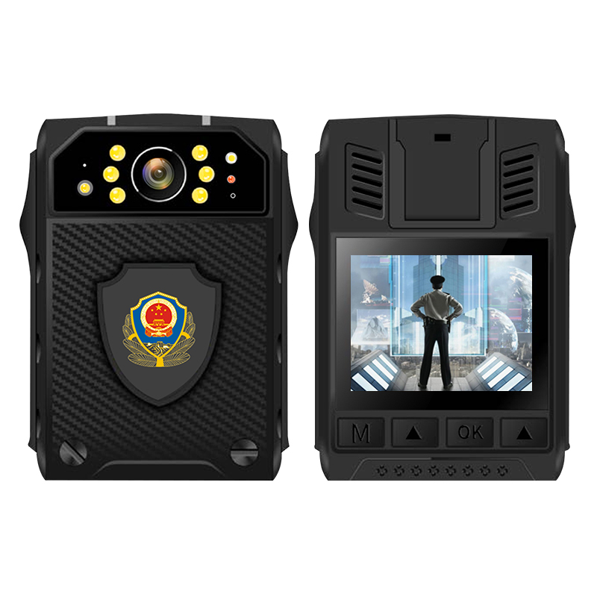

**Key Features:**

→Mstar Chip

→Up to 1920X1080P 30fps video resolution

→Support H.264 and H.265 video compression

→Up to 20 million pixels for snap shot

→170° wide angle of view

→Support night vision, up to 10 meters with visible face image

→Support GPS,

→2500mAh battery capacity for 9 hours 1080P 30fps recording(H.265)

→IP66

→Pre-record(60s) and Post-record(5s/1min/10min/20min/35min)

**→50% storage saving(H.265) and lower power consumption**

→Support lock mode during recording and motion detection function

→2 inch TFT-LCD high-resolution color display

→88mm*58mm*26.5mm and 130g

|  |  |
| --- | --- |
| **Model NO.** | **LS-BC32** |
| Chipset | Mstar Chip |
| OS | Linux |
| H.265 | Support H.265 (50% storage saving) |
| Image Sensor | 2MP CMOS sensor (OV4689) |
| Image Angle | 170° |
| Recording Resolution | 1920x1080/30fps,1280x720/30fps,848x480/30fps |
| Video Format | H.264/ H.265 MPEG4 |
| Photo Format | JPEG, up to 34M (8448*4752. 16:9) pixel |
| LionScripts | It can be connected to mobile APP through WiFi to realize wireless control of recording, taking photos, downloading and playback of videos |
| Snap Shot | Capture Photos During Video Recording |
| PIV | Off/3/5 (Burst photos during video recording) |
| Self Timer | The amount of time camera waits to take a photo (off/5s/10s/20s/30s/1min) |
| One Button Recording | Support |
| Audio Microphone | High Quality Build-in Dual Microphone. |
| Audio Format | WAV |
| Storage Capacity | 32G |
| Night Vision | 6 IR lights and Up to 10 Meters with Visible face image |
| IR-Cut | Automatic |
| GPS | GPS coordinate recording |
| WIFI Hotspot function | Can be customized |
| Pre-record | 60 seconds pre-record |
| Post-record | 5s/1min/10min/20min/35min/Off |
| Motion Detect | Support |
| Lock mode | Support lock other buttons to avoid accidentally touching them during recording |
| CarDV Mode | Support |
| Loop Recording | Support |
| Audio/Video Playback | Support |
| Fast forward | 2X, 4X, 8X, 16X, 32X, 64X, 128X |
| Rewind | 2X, 4X, 8X, 16X, 32X, 64X, 128X |
| Files length | 3min/5min/10min/15min/30min/45min |
| Important tag | Support tag importance to audio/video file when camera is on recording |
| Photo resolution | 45MP, 36MP, 16MPmillion, 8MP, 5MP, 1080P, save it as a JPEG |
| Battery Capacity | Built-in 2500mAH Lithium |
| Charging time | 180 minutes |
| Charging Dock | For battery charging and data transmission |
| Power Save Mode | Support |
| Waterproof | IP66 |
| LCD | 2.0 inch TFT-LCD High-Resolution Color Display |
| Water Mark | User ID, Time and date Stamp,GPS coordinates Imbedded into Video. |
| Drop grade | The drop resistance grade is greater 2m |
| Parameter settings | LCD menu |
| Auxiliary Light | two white flash lights and one red laser pointer |
| Activation prompt | Audible, Visual, and Vibration to indicate recording start and Stop |
| Indicator LED | 2 lights |
| PTT | Does not support to connect to radios |
| USB | Mini USB,Support USB 2.0 |
| Password protect | Without entering password on camera or via software, user can not get access to camera storage & setting when connect to PC |
| Dimension | 88mm * 58mm * 26.5mm |
| Weight | 130g |
| Working Temperature | -30℃~60℃ |
| Storage temperature | -20℃~55℃ |
| Standard Accessories | Adaptor, USB cable, charging dock, Driver CD，Clip,1pcs backup battery ; |