**LS-ND9503 H.265/H.264 HD IP Camera**

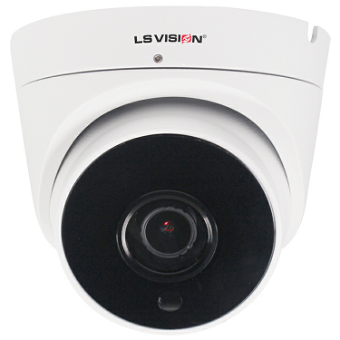

**Features:**

5.0MP H.264 H.265

Solution: SSC337+ 1/2.9" CMOS

→5 MP , 1/2.7" CMOS Sensor

→Standard Fixed lens 3.6mm

→12pcs Leds IR distance 15M, IP66 POE

→5MP@25fps,1080P@30fps

→Built-in Mic

→Optional 2.8/6/8mm lens Add 0.5USD

1. Ultra-low illumination, black light full color HD camera

2. H.264 / H.265 video compression standard

3. support variable bit rate, while setting the video image quality, you can also limit the video image compression bitstream

4. video code rate 50Kbps-6Mbps continuously adjustable, frame rate 1-30 (1-25) continuously adjustable

5. dynamic detection support (settable area and sensitivity)

1. support audio input and output (optional)
2. support multiple user access at the same time
3. support client remote monitoring software
4. support mobile phone monitoring
5. External two-way audio OR Built-in Mic Optional

**Technical Specifications:**

|  |  |
| --- | --- |
| **Model** | **LS-ND9503** |
| **Camera** | |
| Image Sensor | SSC337+ 1/2.9" CMOS |
| Pixels | 2592(H)×1944(V) |
| Image Quality | Brightness setting, Saturation setting, Sharpness setting, Contrast setting, Auto white balance, Manual white balance setting, Backlight compensation setting, Light suppression setting, Auto exposure, 2D/3D noise reduction intensity setting, Fog mode setting, WDR mode Strength setting |
| Min. Illumination | 0.001Lux@F1.2(AGC ON) |
| Day/Night | Color/(B/W)/Timing |
| WDR | Digital WDR |
| White Balance | Auto |
| AGC/BLC | Support |
| DNR | 2D/3D DNR |
| Other | Multi-lines OSD, Motion Detection, Privacy Mask, Mirror, Rotate |
| **Encode** | |
| Embedded Solution | SSC337 |
| Video Standard | H.265/H.264 Double code |
| Video Resolution | Main stream:1920*1080，1-20fps ; 1280*720,1-30fps  Sub stream:640*480/640*360 ,1-30fps |
| Video Bitrates | 32Kbps-5Mbps, VBR/CBR |
| Audio Standard | G.711-u |
| OSD Overlay | Title and Time overlay |
| **IR Led** | |
| IR Led | N/A |
| IR Distance | 15-50M |
| **Lens** | |
| Focal length | 3.6mm Fixed lens |
| Zoom | No |
| **Optional Function** | |
| Audio, etc. | |
| **Network Services** | |
| Protocol | HTTP/RTSP/FTP/PPPOE/DHCP/DDNS/NTP/ONVIF/P2P/UPNP |
| P2P | Yes |
| Web | IE , Firefox, Chrome etc. |
| Media | CMS, Android, IOS |
| ONVIF | 2.6 compatible |
| **General** | |
| Network Port | 1-RJ45, 10/100Mbps |
| Power Supply | Support POE 48V 12 VDC ± 10% |
| Power Consumption | < 5 W |
| Operating Temp. | -30℃-(+60)℃, 10%-90%RH |
| Waterproof level | IP66 |

*This statement is subject to change without notice