**LS-ND15301 HD 3.0MP IP Camera**

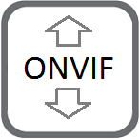 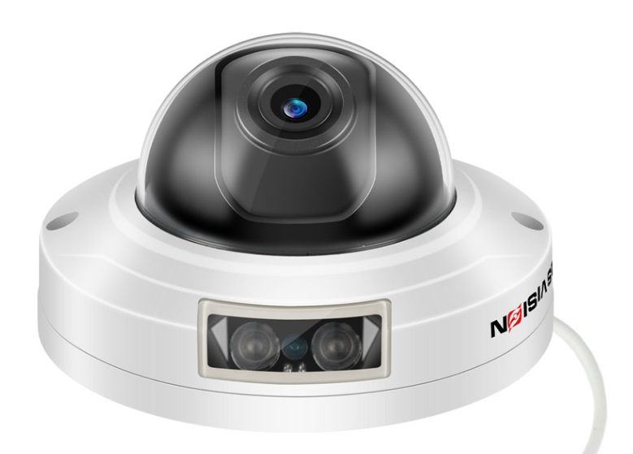

**Features:**

* 1/2.7" UHD CMOS sensor
* Max. 3MP resolution 2304 x 1280
* low illumination 0.01Lux
* Day/Night (ICR), AWB, 2D/3D-DNR, IR-CUT
* D-WDR, Motion Detection, Privacy Mask, Mirror, rotate
* RTSP and Onvif 2.6 compatible
* H.265/H.264 dual-stream media server 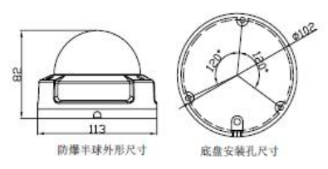
* Easy-to-use P2P Cloud service
* Multi web browser, PC Client, mobile APP remote access
* Optional customization Lens/Audio/ POE, etc.
* Lightning protection 4000V
* Strong water-proof housing, IP66
* 12 pcs IR Leds, IR distance 20 meters
* 3.6 mm fixed lens

**Technical Specifications:**

|  |  |
| --- | --- |
| **Model** | **LS-ND15301** |
| **Camera** | |
| Image Sensor | 1/2.7" 317 CMOS |
| Effective Pixels | 2304(H)×1280 (V) |
| Electronic Shutter | AUTO, 1/25s ~ 1/100000s |
| Min. Illumination | 0.01Lux@F1.2(AGC ON), 0Lux IR on |
| Day/Night | Auto/Color/(B/W)/Timing |
| WDR | Digital WDR |
| White Balance | Auto |
| AGC/BLC | Support |
| DNR | 2D/3D DNR |
| Other | Multi-lines OSD, Motion Detection, Privacy Mask, Mirror, Rotate |
| **Encode** | |
| Embedded Solution | SSC335 |
| Video Standard | H.265/H.264 |
| Video Resolution | Main Stream:  25fps@3MP(2304 x 1280),30fps@2MP/1080P/720P  Sub Stream: VGA(640x480)/360P/QVGA@30fps, etc. |
| Video Bitrates | 32Kbps - 6Mbps, VBR/CBR |
| Audio Standard | G.711-u/G.711-a |
| **IR Led** | |
| IR Led | 12 pcs IR Leds |
| IR Distance | 20M |
| **Lens** | |
| Focal length | 3.6mm fixed lens |
| Zoom | no |
| **Optional Function** | |
| POE, Audio, etc. | |
| **Network Services** | |
| Protocol | HTTP/RTSP/FTP/NFS/SMTP/DHCP/NTP, etc. |
| P2P | Yes |
| Web | IE , Firefox, etc. |
| Media | CMS, Android, IOS |
| ONVIF | 2.6 compatible |
| **General** | |
| Network Port | 1-RJ45, 100Mbps, |
| Power Supply | Support POE 48V& 12 VDC ± 10% |
| Power Consumption | < 7 W |
| Operating Temp. | -20℃-(+60)℃, 10%-90%RH |

*This statement is subject to change without notice